One Page Report
20:45 20:50 20:55 21:00 21:05 21:10 21:15 21:20 21:25
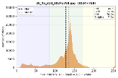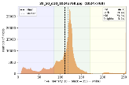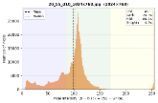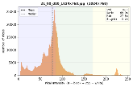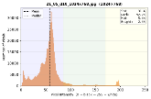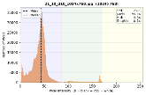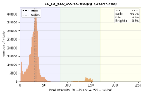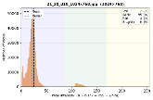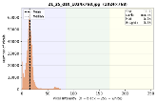
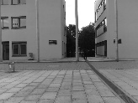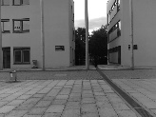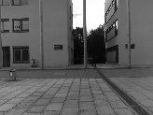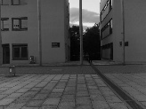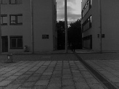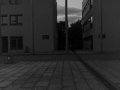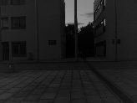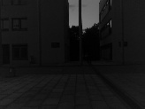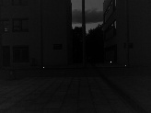
Figure A: Transition of light
The image gets harder to be processed/ analyzed as the light intensity decreases.
The graph demonstrates how the pixel concentration/ information moves as the light conditions change from bright to dark.
The images are taken between 20:00 and 21:00: the time slots are 20:00, 20:16, 20:30, 20:45, 20:52, 20:55, 20:58 and 21:00 (CET)
The shift in the pixel concentration is more observed from the time slot starting from 20:45 to 21:00 (CET)

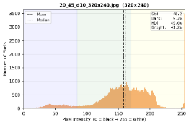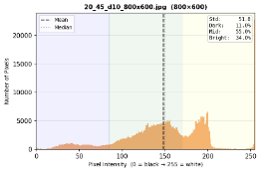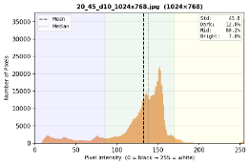
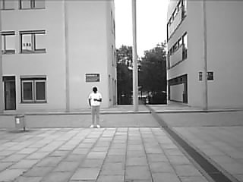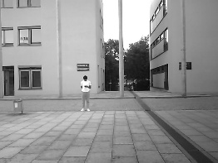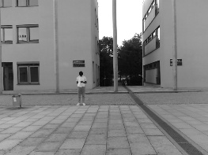
Figure B: Comparision of Resolution
The above image shows the comparison between the resolution at same time slot (20:00 CET).
This shows how the number of pixel changes and how the pixel intensity distribution is for different resolution.
The resolutions are: 1024x768, 800x600 and 320x240

Clear Background YOLO Values
Distance | Resolution | 20:45 | 20:50 | 20:55 | 20:57 | 21:00 | 21:02 | 21:05 | 21:07 | 21:10 | 21:12 | 21:15 | 21:17 | 21:20 | 21:22 | 21:25
10m | Low (320x240) | 0.73 | 0.83 | 0.67 | 0.84 | 0.83 | 0.84 | 0.85 | 0.83 | 0.77 | 0.84 | 0.83 | 0.87 | 0.87 | 0.85 | 0.81
 | Mid (800x600) | 0.86 | 0.87 | 0.86 | 0.89 | 0.88 | 0.87 | 0.88 | 0.88 | 0.88 | 0.89 | 0.88 | 0.89 | 0.87 | 0.87 | 0.89
 | High (1024x768) | 0.87 | 0.88 | 0.89 | 0.89 | 0.86 | 0.89 | 0.89 | 0.88 | 0.89 | 0.87 | 0.87 | 0.88 | 0.87 | 0.86 | 0.88
15m | Low (320x240) | 0.70 | 0.46 | 0.82 | 0.73 | 0.86 | 0.79 | 0.79 | 0.00 | 0.67 | 0.71 | 0.80 | 0.00 | 0.00 | 0.37 | 0.43
 | Mid (800x600) | 0.83 | 0.82 | 0.83 | 0.83 | 0.82 | 0.80 | 0.82 | 0.84 | 0.82 | 0.85 | 0.85 | 0.84 | 0.84 | 0.81 | 0.82
 | High (1024x768) | 0.83 | 0.83 | 0.84 | 0.83 | 0.85 | 0.81 | 0.84 | 0.85 | 0.85 | 0.85 | 0.84 | 0.82 | 0.83 | 0.82 | 0.80
20m | Low (320x240) | 0.00 | 0.00 | 0.60 | 0.00 | 0.00 | 0.00 | 0.00 | 0.00 | 0.00 | 0.00 | 0.00 | 0.00 | 0.00 | 0.00 | 0.00
 | Mid (800x600) | 0.00 | 0.00 | 0.00 | 0.00 | 0.00 | 0.00 | 0.00 | 0.00 | 0.00 | 0.00 | 0.00 | 0.00 | 0.00 | 0.00 | 0.00
 | High (1024x768) | 0.50 | 0.00 | 0.00 | 0.00 | 0.00 | 0.00 | 0.00 | 0.00 | 0.00 | 0.00 | 0.00 | 0.00 | 0.00 | 0.00 | 0.00

Noisy Background YOLO Values
Distance | Resolution | 20:45 | 20:50 | 20:55 | 20:57 | 21:00 | 21:02 | 21:05 | 21:07 | 21:10 | 21:12 | 21:15 | 21:17 | 21:20 | 21:22 | 21:25
10m | Low (320x240) | 0.74 | 0.70 | 0.75 | 0.60 | 0.64 | 0.00 | 0.00 | 0.00 | 0.00 | 0.56 | 0.00 | 0.00 | 0.00 | 0.00 | 0.00
 | Mid (800x600) | 0.86 | 0.80 | 0.78 | 0.81 | 0.82 | 0.80 | 0.81 | 0.79 | 0.79 | 0.76 | 0.74 | 0.71 | 0.00 | 0.62 | 0.00
 | High (1024x768) | 0.89 | 0.84 | 0.84 | 0.84 | 0.82 | 0.80 | 0.81 | 0.81 | 0.81 | 0.80 | 0.71 | 0.67 | 0.00 | 0.00 | 0.00
15m | Low (320x240) | 0.00 | 0.00 | 0.00 | 0.00 | 0.00 | 0.00 | 0.00 | 0.00 | 0.00 | 0.00 | 0.00 | 0.00 | 0.00 | 0.00 | 0.00
 | Mid (800x600) | 0.70 | 0.58 | 0.71 | 0.72 | 0.68 | 0.69 | 0.68 | 0.00 | 0.00 | 0.00 | 0.46 | 0.00 | 0.00 | 0.00 | 0.00
 | High (1024x768) | 0.65 | 0.66 | 0.66 | 0.70 | 0.66 | 0.51 | 0.51 | 0.54 | 0.58 | 0.37 | 0.00 | 0.00 | 0.00 | 0.00 | 0.00
20m | Low (320x240) | 0.00 | 0.00 | 0.00 | 0.00 | 0.00 | 0.00 | 0.00 | 0.00 | 0.00 | 0.00 | 0.00 | 0.00 | 0.00 | 0.00 | 0.00
 | Mid (800x600) | 0.54 | 0.56 | 0.00 | 0.49 | 0.00 | 0.00 | 0.00 | 0.00 | 0.00 | 0.00 | 0.00 | 0.00 | 0.00 | 0.00 | 0.00
 | High (1024x768) | 0.35 | 0.00 | 0.00 | 0.00 | 0.00 | 0.00 | 0.00 | 0.00 | 0.00 | 0.00 | 0.00 | 0.00 | 0.00 | 0.00 | 0.00

